**Task 3:**

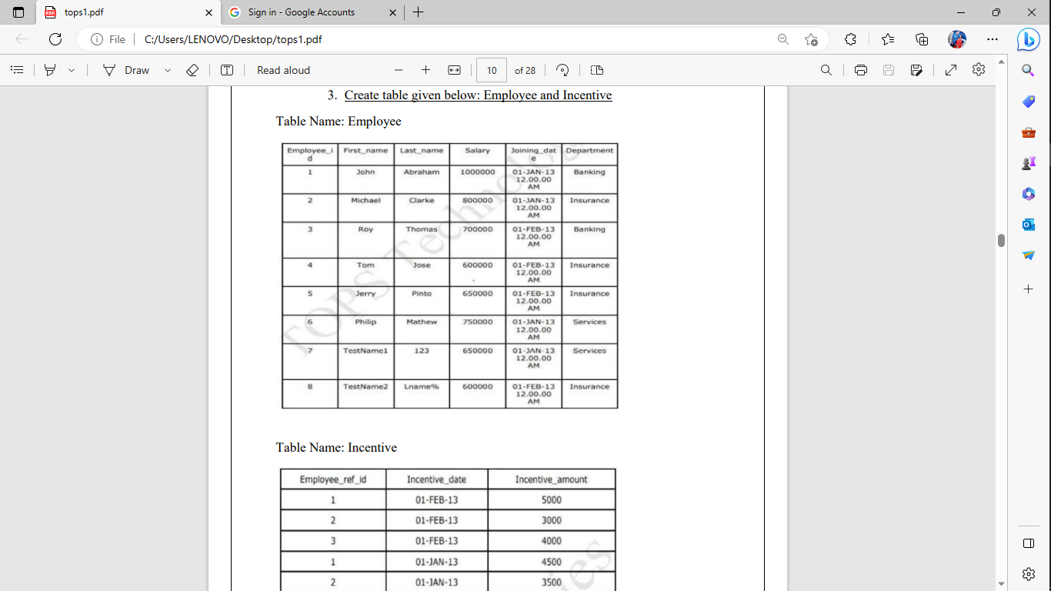

**solution:🡪**

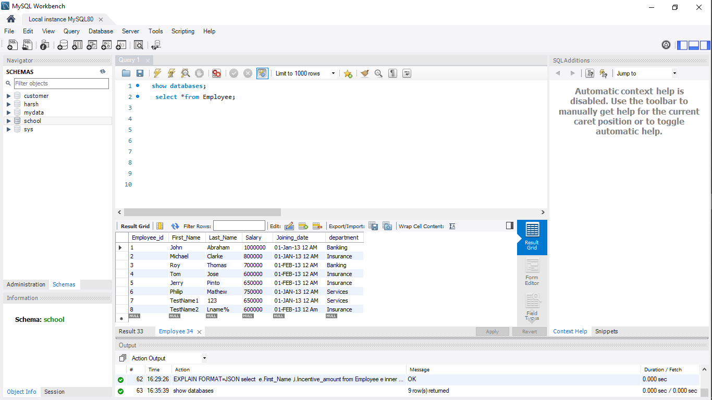

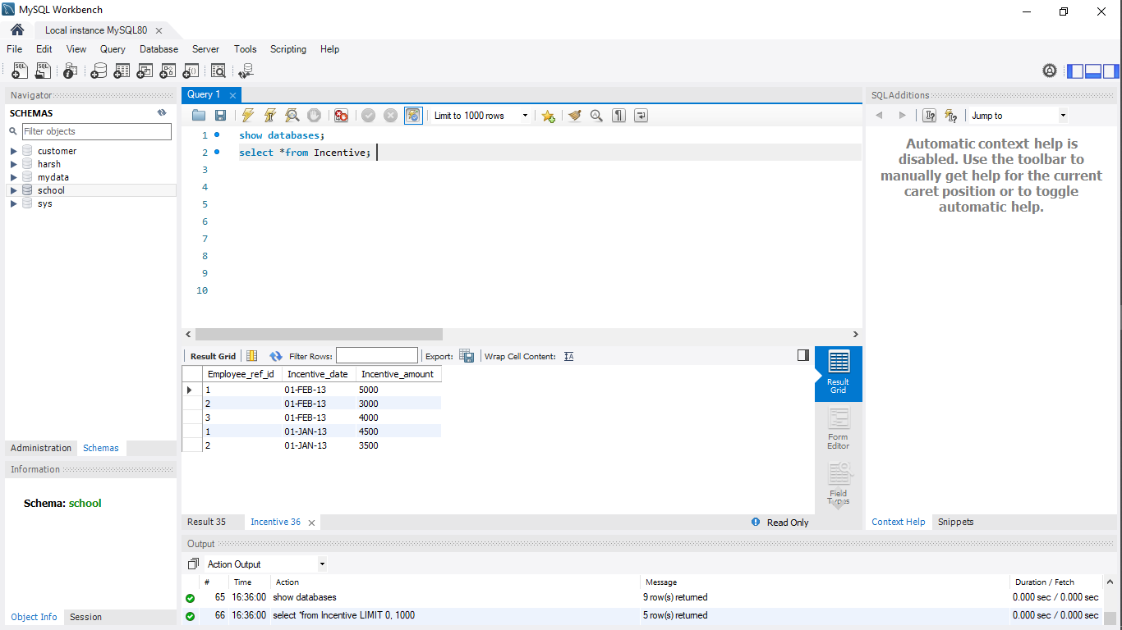

**a) Get First_Name from employee table using Tom name “Employee Name”.**

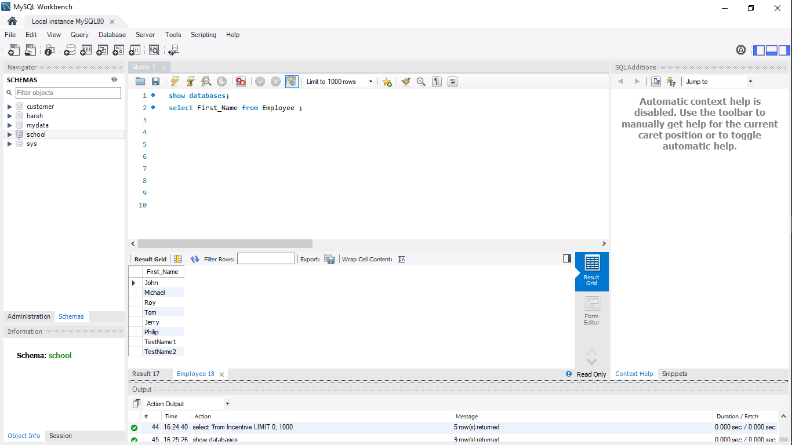

**b) Get FIRST_NAME, Joining Date, and Salary from employee table.**

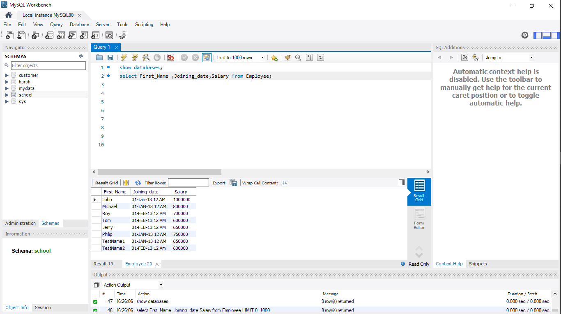

**c) Get all employee details from the employee table order by First_Name Ascending and Salary descending?**

**Table1 Ascending :--**

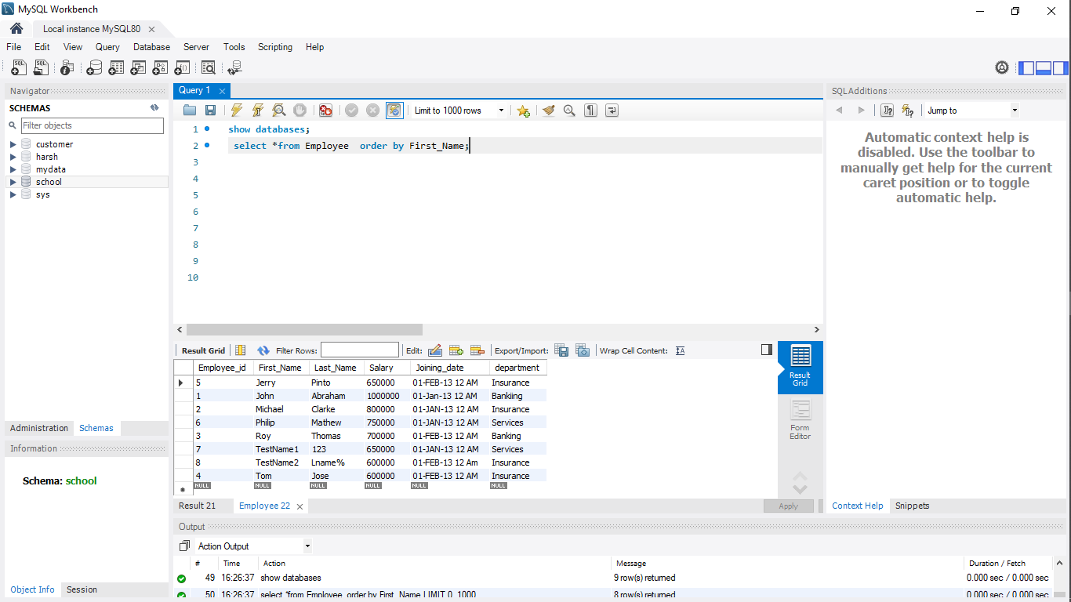

**Table2Descending :--**

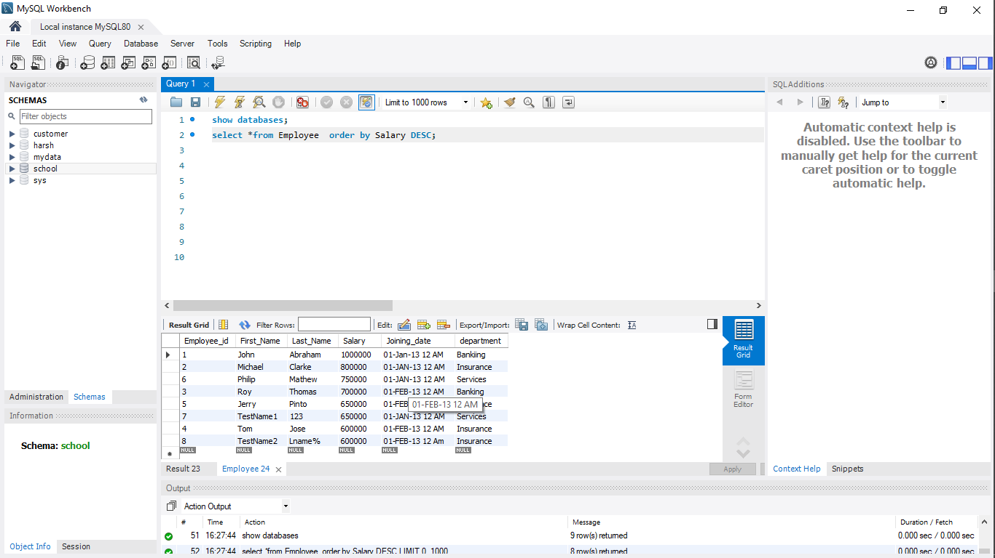

**d) Get employee details from employee table whose first name contains ‘J’**.

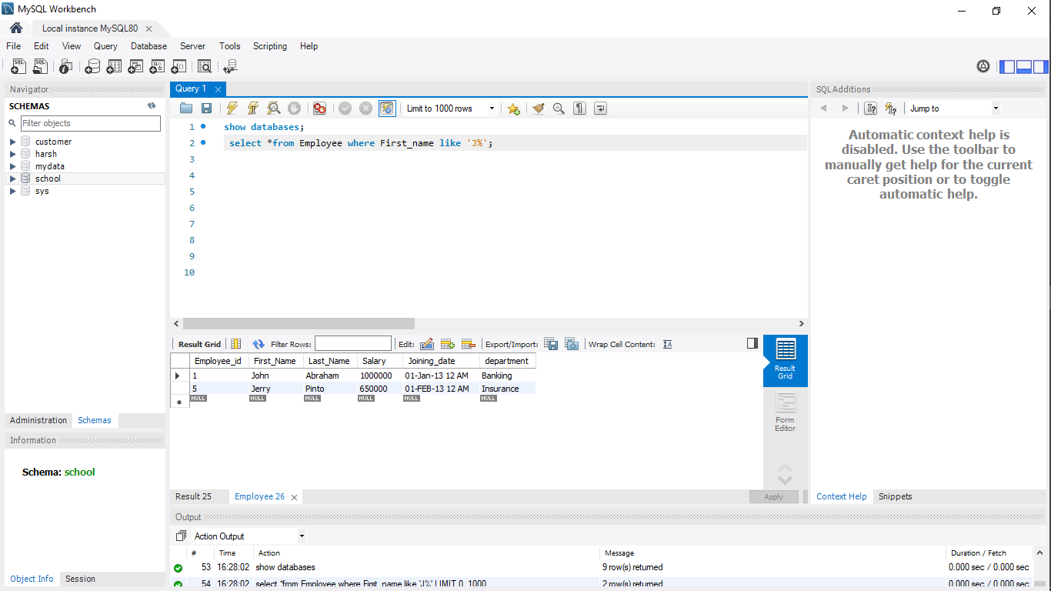

**e) Get department wise maximum salary from employee table order by salary ascending?**

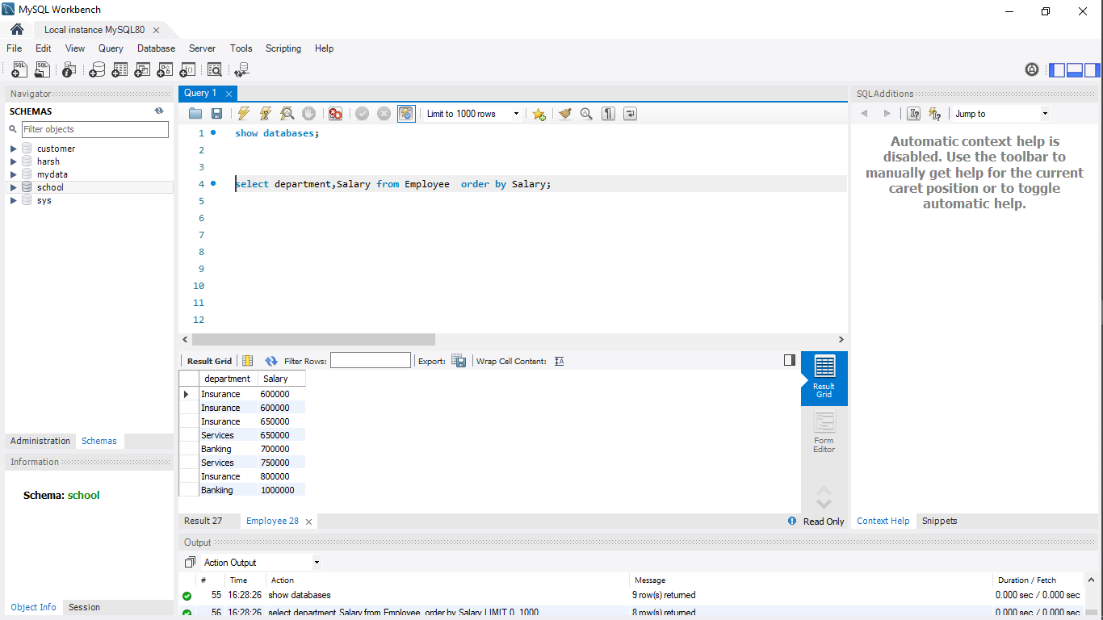

**f) Select first_name, incentive amount from employee and incentives table for those employees who have incentives and incentive amount greater than 3000**

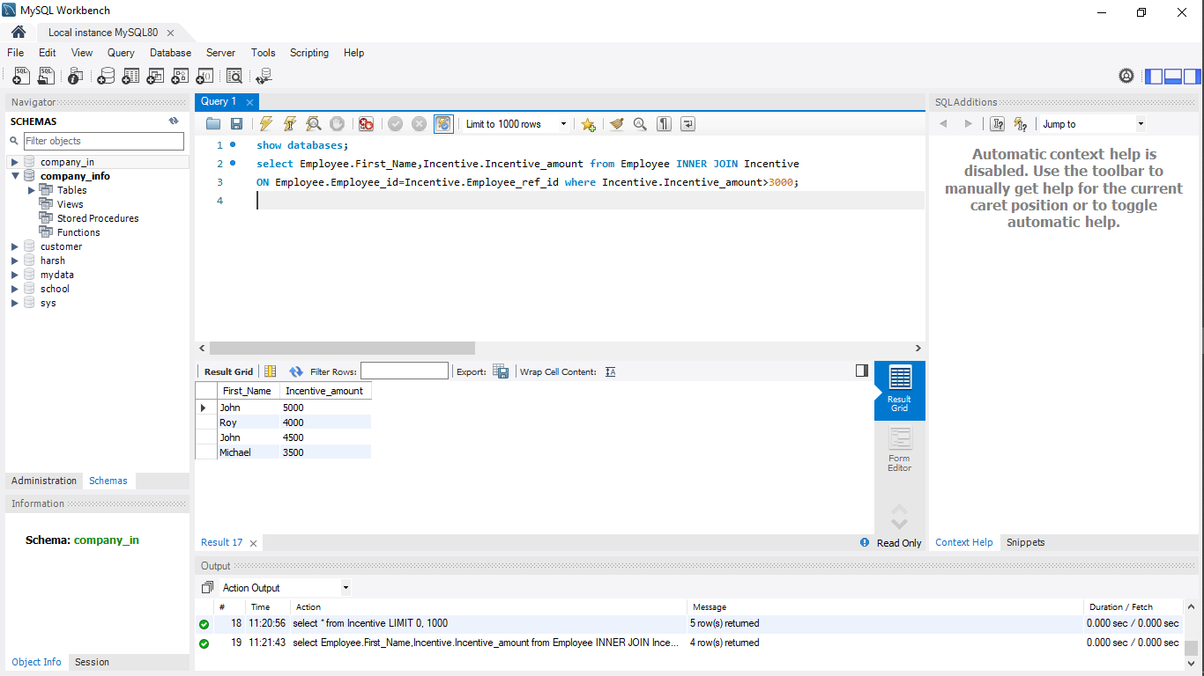

**g) Create After Insert trigger on Employee table which insert records in view table**

